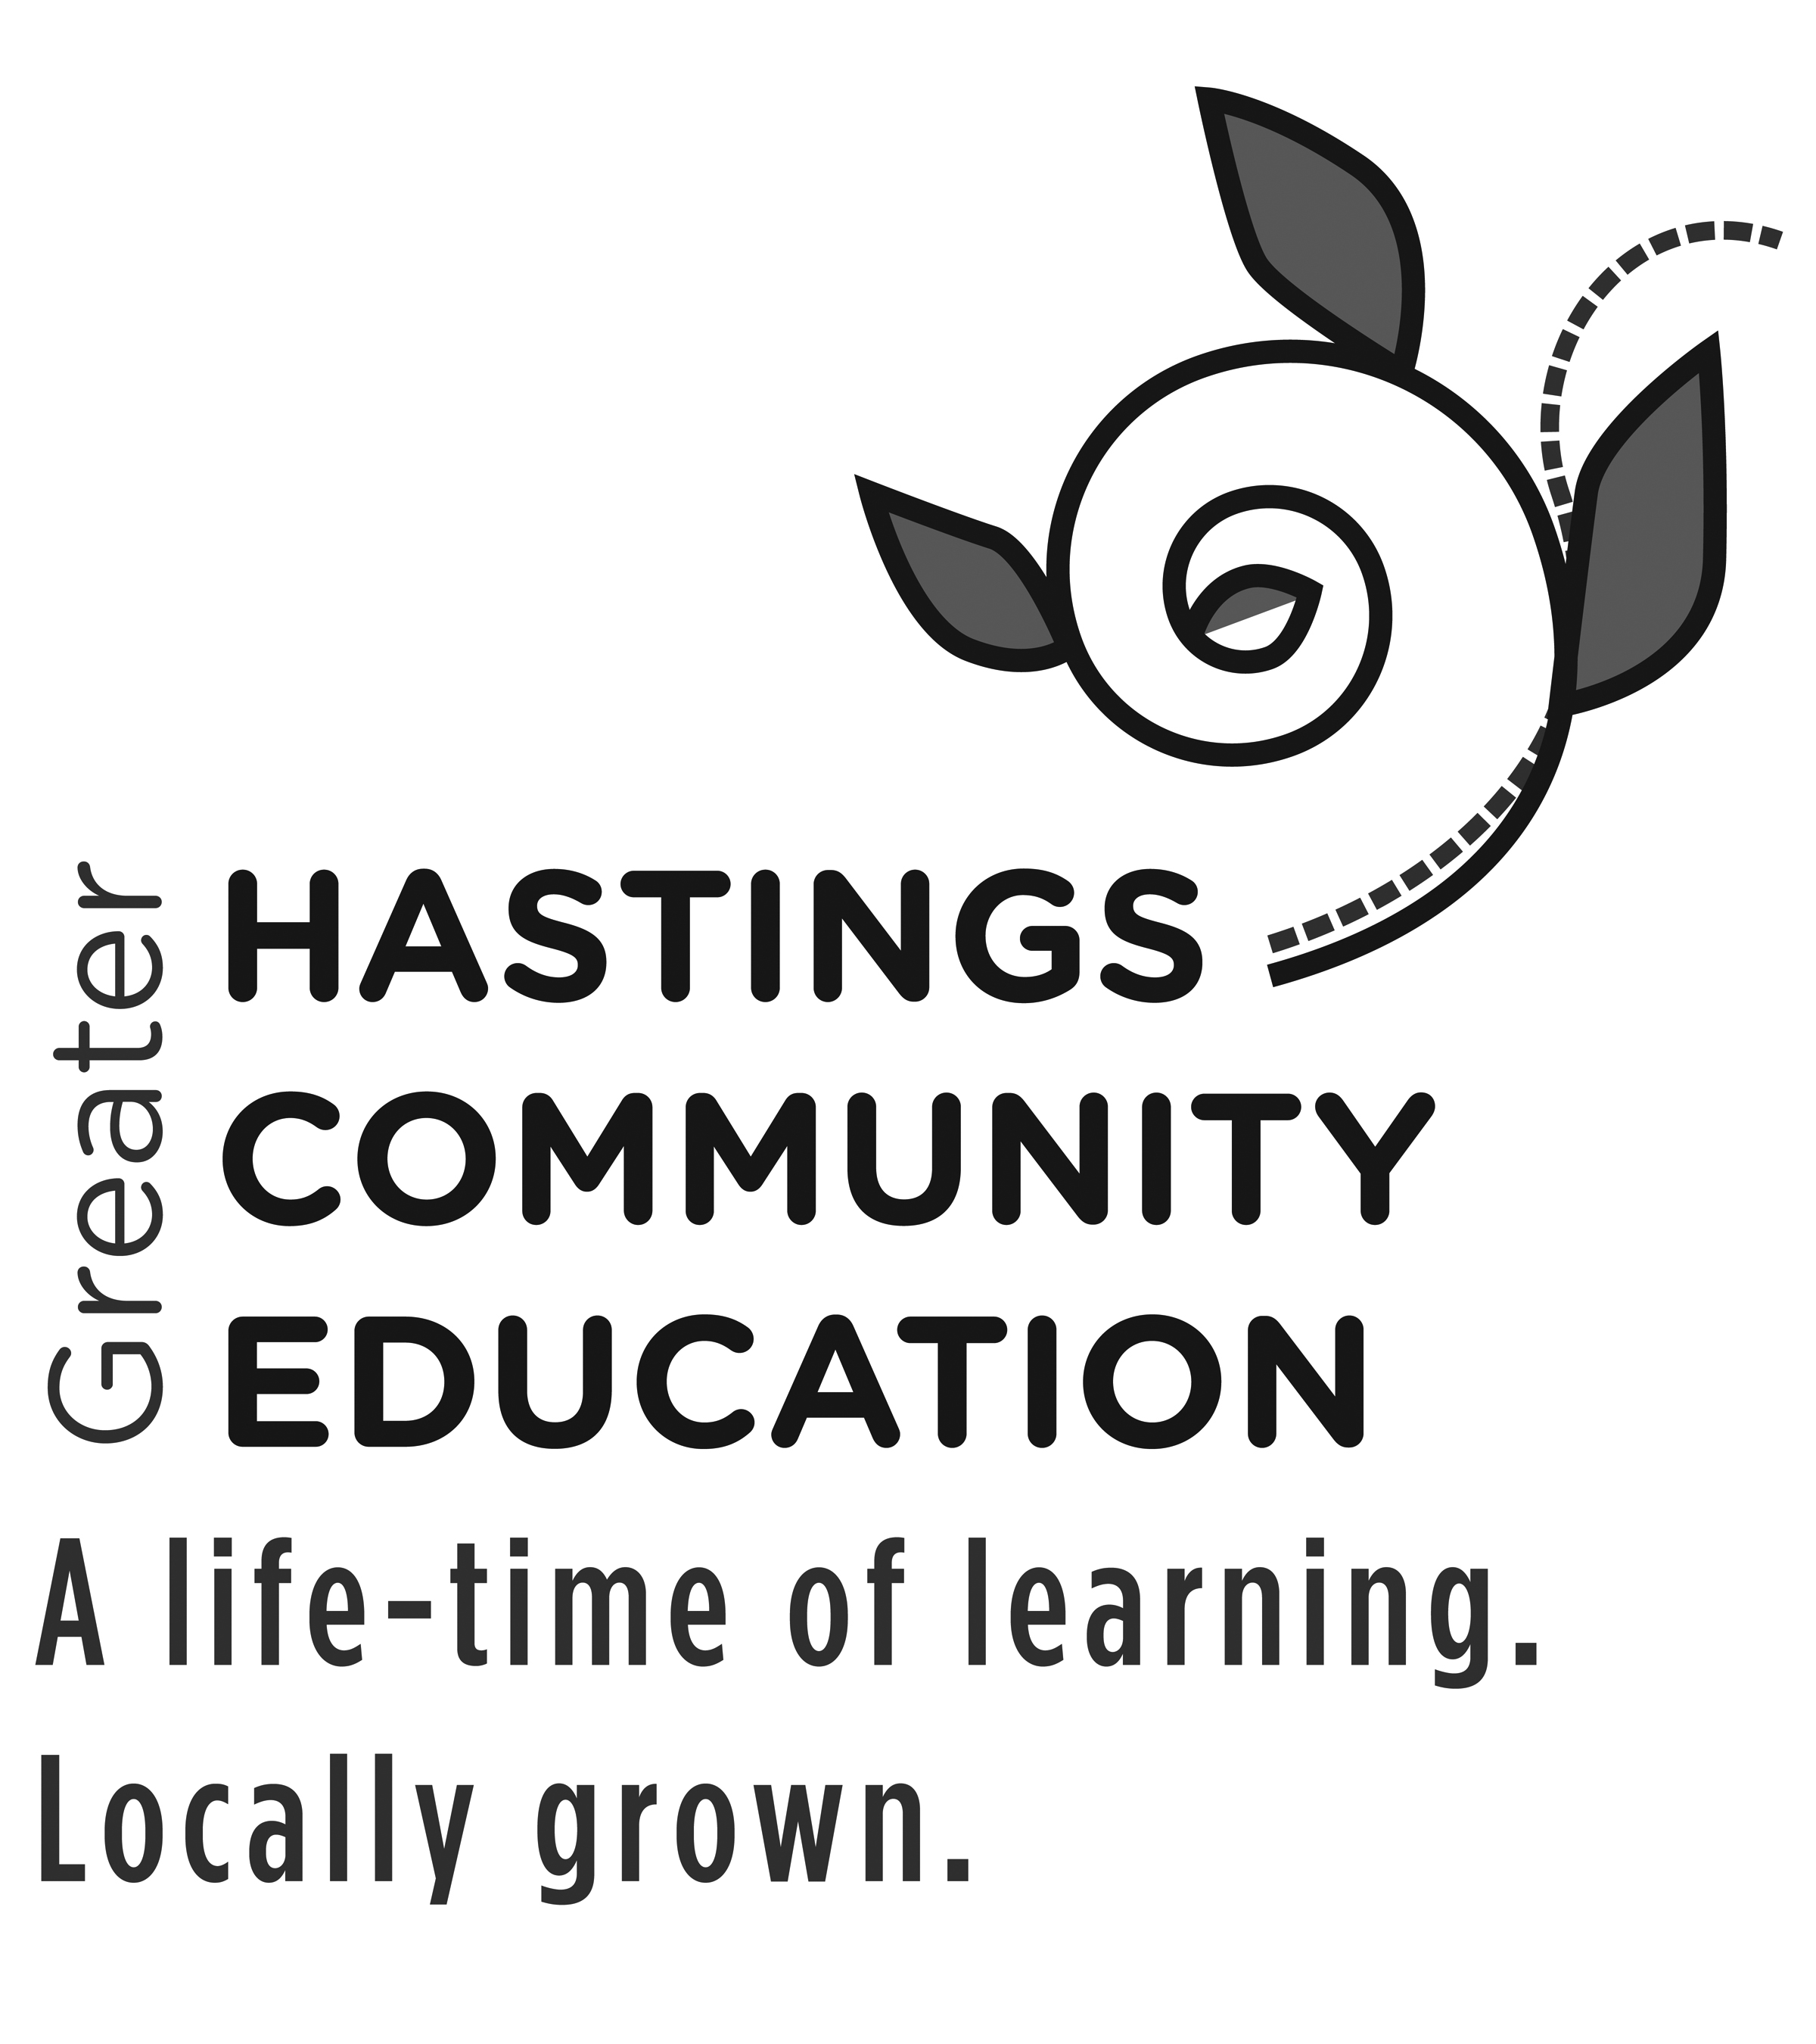
Participant/Spectator/Volunteer Incident Report Form
Complete this incident report if anyone participating in or watching an event you are hosting at a Hastings Public Schools facility becomes injured. Complete a separate form for each person involved.

Name of Injured Person_________________________________________________________________
Age
Parent/Guardian Name (if applicable)_____________________________________________________

Address ______________________________________________________________________________
Street Address City State Zip

Preferred Phone Number _______________________________________________________________

Email Address (if applicable)_____________________________________________________________

Location, Date and Time of Injury_________________________________________________________

Type of Incident: Cut/Bruise Fall Burn Broken Bone Sprain/Strain Confrontation

Were Police/911 contacted? ________________Time __________________ Ambulance Sent?_______

Describe Incident/Injury:

Was first aid administered? By whom?____________________________________________________

Was an emergency contact for the injured notified? Who?____________________________________

Witnesses (if any)
Name ______________________________________________________ Phone____________________

Name_______________________________________________________ Phone___________________

Printed Name of Person Making Report__________________________________________Date______

Signature of Person Making Report___________________________________________Date Sent_____

SEND IMMEDIATELY TO: Mary O’Brien, Director of Community Education
mobrien@hastings.k12.mn.us; FAX 651-480-7680
Tilden Community Center, 310 River Street, Hastings, MN 55033. 651-480-7670

